Jumper Settings for Output Voltage Range Input Signal: 0-20mA:
- 0-3.3V: J1 1,2 pin are short circuit connected; 3, 4 pins are short circuit connected
- 0-5V: J1 1,2 pin is a short circuit connected; 3, 4 pins are short circuit connected
- 0-10V: J1 1,2 pin are short circuit connected; 3, 4 pins are disconnected
Jumper Settings for Output Voltage Range Input Signal: 4-20mA
- 0-2.5V: J1 1,2 pin are short circuit connected; 3, 4 pins are short circuit connected
- 0-3.3V: J1 1,2 pin are disconnected; 3, 4 pins are disconnected
- 0-5V: J1 1,2 pin is a short circuit connected; 3, 4 pins are short circuit connected
- 0-10V: J1 1,2 pin is a short circuit connected; 3, 4 pins are disconnected

APPLICATION
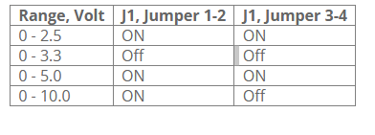
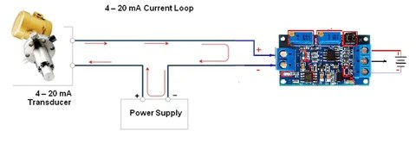
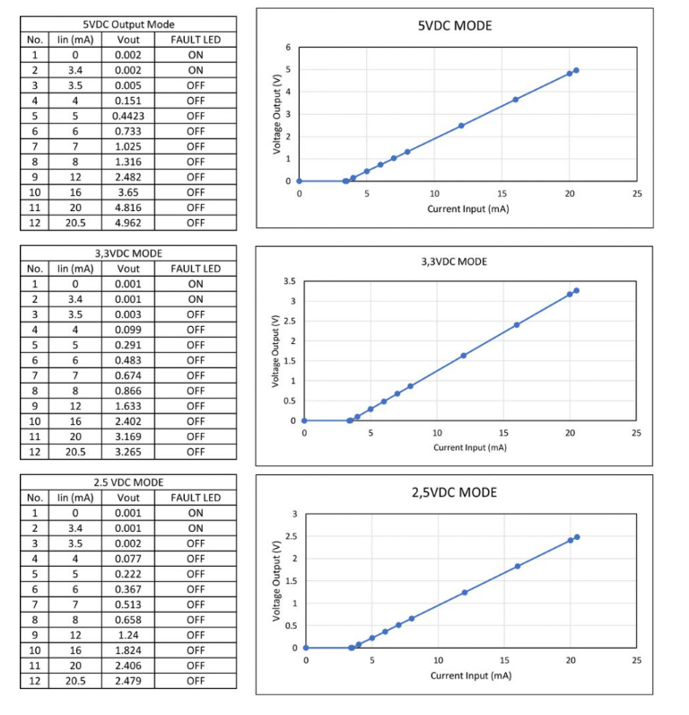
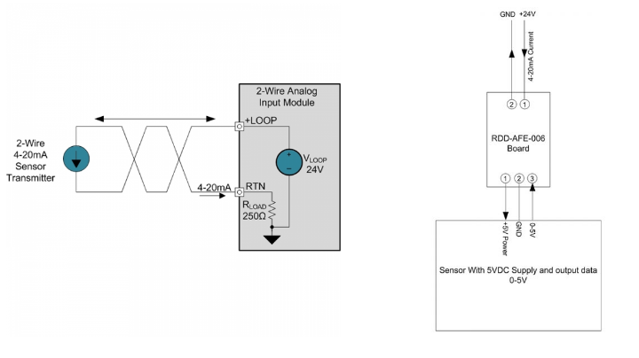
ambar 21. Modul Sensor Soil Moisture

